Introduction to Software Design Specification (SDS)

Flarem submitted its comprehensive proposal to the institutional tender regarding the development of a streamlined communication solution for modern student engagement. The proposal was formally accepted during Phase 1 of the project on 12 November 2025. Under this agreement, Flarem will develop Forumium, a dedicated web-based forum platform designed to centralize student discussions, peer-to-peer support, and administrative announcements within a secure and innovative digital environment. This project aims to transition the client from traditional, fragmented communication methods to a sophisticated technological ecosystem that prioritizes data integrity and community safety.

The current operation of student communication involves two major risks that hinder the efficiency of the academic environment. Firstly, there is a significant issue with information fragmentation and digital congestion, where vital academic updates are lost within unorganized social media groups and unofficial messaging channels. Secondly, the existing reliance on physical bulletin boards and manual inquiry systems creates unnecessary administrative bottlenecks and physical crowding at information desks. These legacy systems are no longer sufficient for the growing student population and the complexities of modern campus life.

With the rapid digital transformation of the education sector, the institution has observed a great influx of digital traffic as well as increased demand for real-time interaction. The top management of the organization strives to create a safe and organized experience for the students, ensuring that the exchange of information is both controlled and accessible. By implementing Forumium, Flarem will provide a structured web application that eliminates the chaos of unofficial channels, replacing them with a moderated, high-performance platform that fosters a secure intellectual community.

1.1 Forumium Platform Overview
Forumium is a web-based forum application designed to enhance the academic experience by providing a centralized digital space for students to collaborate, share resources, and engage in peer-to-peer learning. By moving academic discussions to a structured online environment, the platform eliminates the fragmentation of information found in casual messaging apps. Forumium offers a streamlined, accessible technological solution that fosters community engagement while allowing students to seek help and share knowledge asynchronously.
The software consists of:
- Web-based Interface: A responsive frontend for seamless interaction across devices.
- Database Hosting Server: A secure backend to manage user data, discussion threads, and media attachments.
- Account Management System:
  - Student Account: To create discussion threads, reply to posts, and join specific academic interest groups.
  - Moderator Account: To manage content, flag inappropriate posts, and ensure community guidelines are upheld.
  - Admin Account: To oversee system health, manage user roles, and analyze platform engagement metrics.
1.2 Document Description
1.2.1 Introduction
1.2.1.1 Purpose
This Software Design Document (SDD) provides the development team with a comprehensive blueprint of the Forumium architecture to streamline the implementation phase and mitigate technical debt. It outlines the platform’s user personas, hardware requirements, and the technical frameworks utilized in its construction. This document serves the following critical functions:
- To provide a functional and architectural perspective to the developers.
- To define the structural components of the forum and the logic behind post-threading.
- To serve as a benchmark for the assessment and evaluation of the final platform.
- To provide a framework for simulating user interactions during the testing phase.
- To verify that the platform meets the specific collaborative needs of the student body.
- To facilitate efficient maintenance and feature updates after the initial launch.
1.2.1.2 Scope
- This document provides high-level abstraction diagrams and data-flow schemas that are directly translatable into code.
- Detailed specifications regarding the hosting environment, database management systems, and frontend/backend frameworks are included.
1.2.1.3 Intended Audience
This document is intended for the Development Team (Frontend, Backend, and Database Engineers), the Quality Assurance (SQA) Team, and the User Experience (UX) Testing Team.

System Overview
The basic design approach to the Forum Web Platform is by utilizing a browser base environment, student and users could access the website through their devices to post discussion, question and articles. These will then be stored in the database. The moderator will manage and moderate the post from users. The following figure gives an illustration of the roles involved for the system.

Forumium Web Platform System Diagram
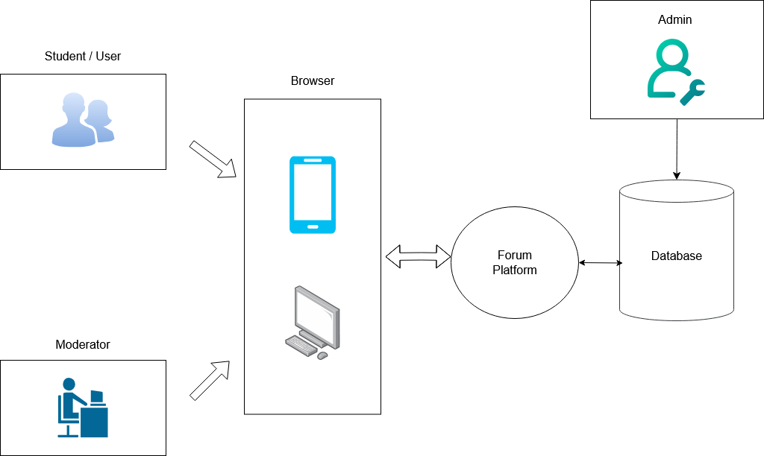

User accounts can post their discussion to the platform. User post are moderated by moderator. The Admin account manages the user accounts and roles, and the database repository.

Web Technology Overview

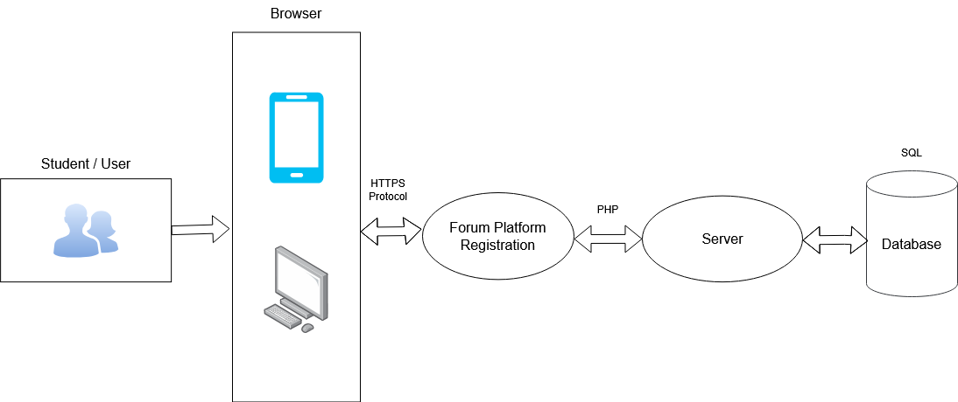
The technology that is deployed to build the system are illustrated in the figure above. Users, who will access the system through a browser, will connect to the website via Hypertext Transfer.
Protocol Secure (HTTPS), which provides a secure connection to the internet. The website is served by mainly three languages: HyperText Markup Language (HTML), Cascading Style Sheets (CSS) and Javascript. These three languages provide a landing page for the user as well forming the basis of User-Interface/ User-Experience (UI/UX) of the website. PHP: Hypertext Protocol powers the website with flexibility and interactivity by being a scripting language that is invoked upon user’s command. The Relational Database Management System (RDBMS) chosen is the MySQL database, which provides high scalability and high availability to the web app.

2.0 Design Considerations
2.1. Assumptions and Dependencies

The web application is assumed to run on any version of Microsoft Windows Server or any operating system like Linux which can operate a web server and support the execution of PHP language. Other than that, it is assumed that the user can utilise the web application using any electronic device such as a mobile phone or computer that supports an Internet connection and the user knows how to access and navigate the website. The biggest assumption is that the web application is planned to be extended to support a new feature based on the needs of our client. It is certain that additional functionality will be added to the proposed web application. In the matter of dependencies, the proposed application is dependent on the two servers to be capable of storing the required data. One of the servers is used for the data backup, in which there will be a domain that can be used by the clinic for the web interface by the potentialcustomers. It is necessary for the web interface to have the right to access the database of theclinic’s capacity at a particular time. Other than that, the web interface used by the customersshould have a workstation with a stable Internet connection.
2.2. General Constraints
In terms of network connectivity, there is a constraint identified with this project. This constraint may exist due to the stability of the Internet network connection from the end-user. It can occur when there is a loss of Internet connection or server downtime during any active session from the user. To rectify this error, the users are required to log in and enter their password again before they can resume booking an appointment. Hence, during this time, an error message will appearon the screen depending on the occurrence of the error, such as “temporarily lost networkconnection” or “Server not found”.
2.3. Goals and Guidelines

The following goals must be addressed in the execution of the proposed web application.

2.3.1 Ease of Use
The system must be easy to use and provide a strong user experience. The users must be able to feel like they can navigate the web page and be able to comprehend how the system works to book their desired time slot for their appointment. As stated in the software requirement document, the number of clicks to make each transaction made by the user should be minimized.

2.3.2 Extensibility
The proposed system’s features must be extensible such as the new features and modifications on the application can be enabled as required by the users.

2.4. Development Methods
The system is designed by taking into consideration of several methods as listed below:

2.4.1 Reliability
To prevent any inaccuracy in the information provided by the system, regular checking
will be done by the developers allow properly function application. This is also to ensure that the users will not be disrupted by any inconsistency.

2.4.2 Security
The users will be able to enter their information details safely without having to worry about data breaches, which will result in discrepancies in our product’s reputation. We aim to protect the data of the users by allowing only authorized persons such as the administrators to access the information.

2.4.3 Flexibility
The users must be able to access the web application using any electronic devices such as tablets, smartphones or even laptops. The system should be designed to have the same interface on any device and this is possible because the application is just a web application
2.4.4 Maintainability
Any future development such as modification and new features upon the request or feedback
from the customers will be integrated into the system to ensure the satisfaction of the users and improve the user experience.

3. Architectural Strategies
This section describes the design strategies that affect the overall organization of the appointment web application system and its higher-level structures.

The system is created using CSS, PHP, JavaScript programming languages and attached to a database for information storage and retrieval purposes. The reasons for using the programming languages stated above is that it specifies the information contained in each item on the webpage, allows interactive features to be displayed on the webpage and defines the style for the web page.

Other than that, upon the user’s request to add new functionalities and features, the system can be extended and enhanced further. This is important for our web application to stay relevant as well as improve customer’s experience by launching new features. However, to ensure our target audience can use the new features seamlessly and without any interruption, it is important to test out the features first. In terms of hardware interface, the user is required to have an Internet connection when he/she is accessing the web platform. Meanwhile, for the software interface, it is essential for the database to be consistently updated for every transaction made by the users and for security purposes, only authorized users such as administrators are allowed to access the database to alter or remove the settings. Meanwhile, for error detection and recovery, a test case design will be produced to be used on the software. The SQA team will then use the test case to review, test and audit the software consistently. Audits can be scheduled or unscheduled.

4. System Architecture
This section will provide a good level overview of the web app under development to list the major responsibilities of Flarem. Subsequently, the document provides a detailed component description in the form of a Data Flow Diagram. The primary intuition to this approach is to provide a general understanding of how the web app technology functions, how and why the system is composed as it is and how individual parts work together to create the holistic inter-dependence system.

4.1. Subsystem Architecture
4.1.1 Overview of Client/Server Model of Web App System Architecture

A particular concept important to web app development is the distinction between the client-side and server-side. The internet is largely utilizing this model to serve web users. User devices are connected via a network to a central server to request a service. Based on the request, the central server will locate the corresponding server and then direct the response to the end-user. In the case of web apps, client devices send HTTPS requests to their Internet Service Provider (ISP) server for the web pages and other applications. The server will locate Flarem local server through the Internet Protocol (IP) address and serve up the responses.

Client/Server Model of a Forumium Web Platform
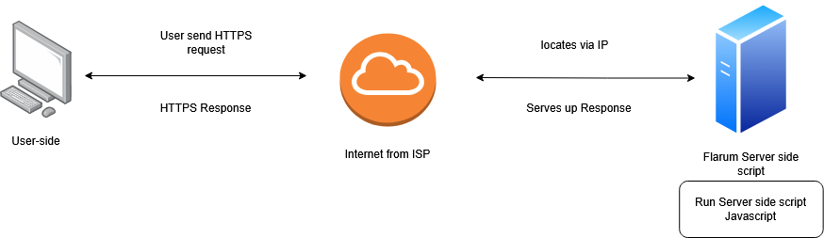

The interactivity and response-ability of the web pages comes from the power of scripting languages. The scripts running in runtime provide greater interactivity to the users than a static content written in HTML. The scripts running in client-side, after the web pages loaded are generally written in Javascript while in the server-side, the language used is PHP.

4.1.2 System Block Diagram of Flarem Local Server

The block diagram provides a simplified overview of Flarem’s local server architecture to
the web app in development.

System Block Diagram for Web Platform

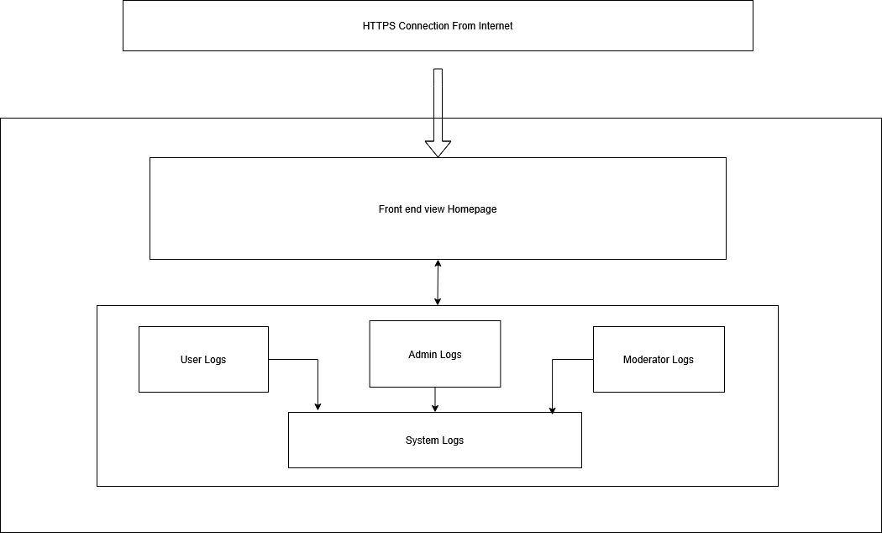

The server will receive HTTPS requests through the public IP address to serve the web page of Appointment Web Application. The PHP scripts on AlphaDevX local server will serve up the webpages. All actions on the server will create a log that is stored in the system log of the
database. These log reports will be used for auditing purposes.

4.1.3 Data Flow Diagram (DFD)

4.1.3.1 Level 0 DFD
The context diagram, aka Level 0 DFD, is a single diagram representing the entire system. The subsequent levels of DFD will explore in detail how each of the processes handles the data flow. The diagram will continue to expand until each “bubble” refers to only a single, simple and executable process.

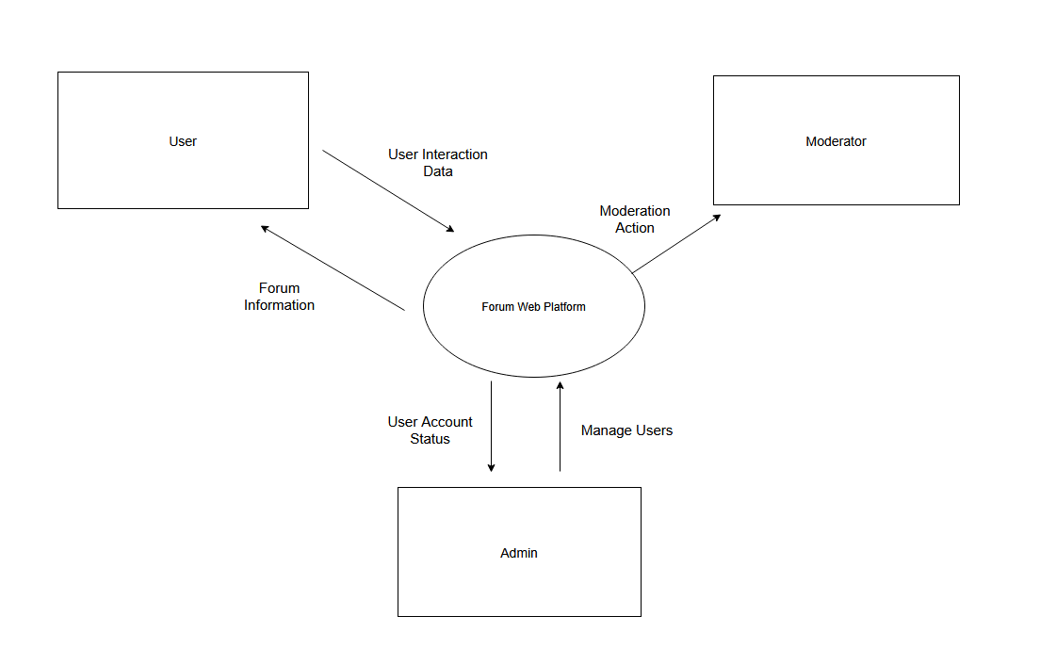

Level 0 DFD - Three external entities

Diagram illustrates three external entities interacting with the Forumium Web Platform, namely the User, Moderator, and Admin.
Users interact with the system to manage their accounts and participate in forum activities such as viewing and creating posts. The system processes these interactions and provides relevant forum information to the users. Moderator interacts with the platform to review and moderate user-generated content to ensure compliance with forum guidelines. Admin is responsible for managing users and overseeing system-related operations. The platform provides user account status and system-related information to the Admin as required.

4.1.3.2 Level 1 DFD

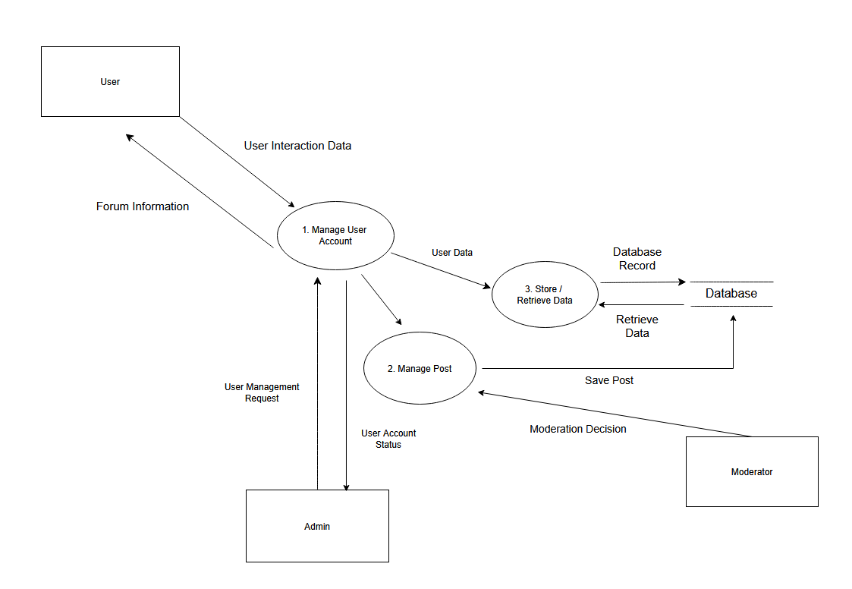
Level 1 DFD – Forumium Web Platform

This Level 1 DFD depicts a student forum platform where Process 1 (Manage User Account) serves as the central hub for student interactions and administrative oversight, handling profile data and account status updates. Process 2 (Manage Post) facilitates content moderation by processing decisions from Moderators to maintain forum standards, while Process 3 (Store/Retrieve Data) acts as the system’s data handler, managing the read/write operations for User Data and content between the functional processes and the central Database. Together, these components ensure that student interactions are authenticated, content is moderated, and all forum activity is persistently stored for reliable retrieval.

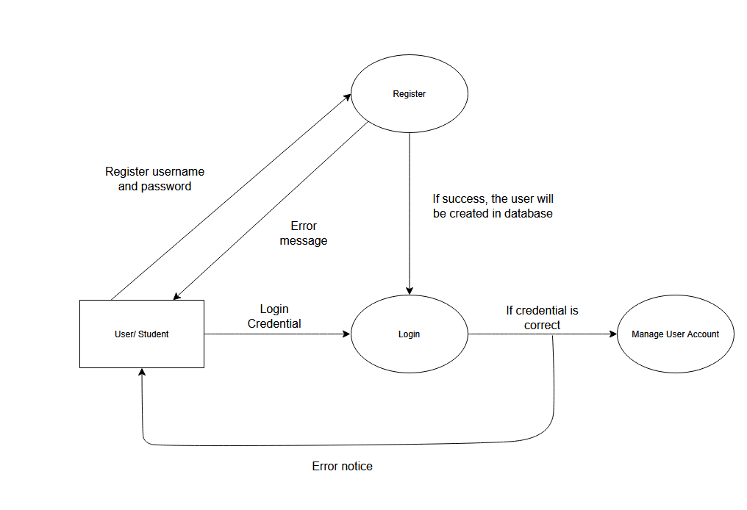
Level 1 - DFD for registration/login

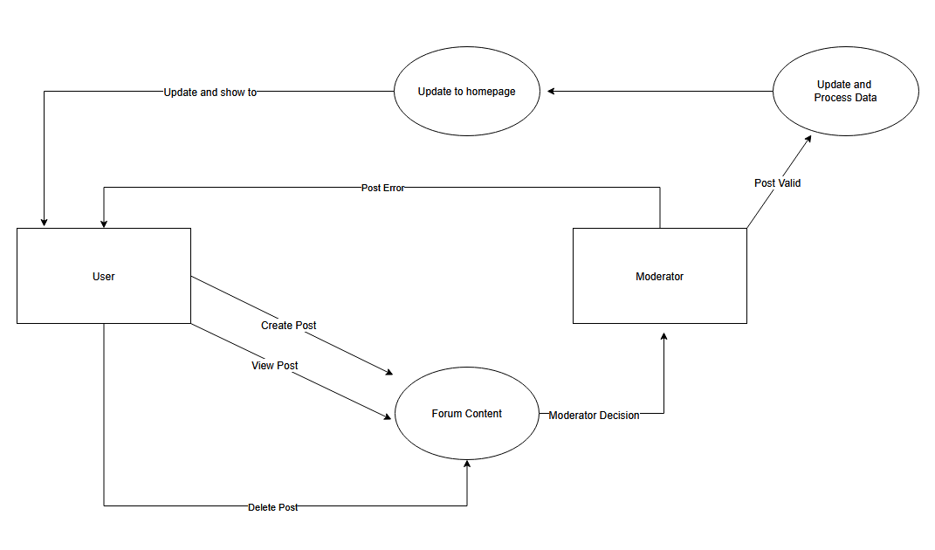
Level 1 - DFD for creating, viewing, delete forum post content

5.0 Data Design

5.1 Data Dictionary
User Table

Attribute | Data Type | Size | Key | Description
user_id | int | - | PK | Unique identifier for each user
username | varchar | 50 | - | User’s display name
email | varchar | 100 | - | User’s email address
password_hash | varchar | 255 | - | Encrypted user password
role | enum | - | - | User role (User, Moderator, Admin)
account_status | enum | - | - | Account status (Active, Suspended)
created_at | datetime | - | - | Account creation timestamp

Name | Type | Default | Example
user_id | int (pk) | Auto Increment | 101
username | varchar(50) | NULL | arashi
email | varchar(100) | NULL | malish@mail.com
password_hash | varchar(255) | NULL | $2b$12$X9
role | enum(user, moderator, admin) | User | User
account_status | enum(active, suspended) | Active | Active
created_at | datetime | CURRENT_TIMESTAMP | 2026-01-01 10:30:00

Post Table

Attribute | Data Type | Size | Key | Description
post_id | int | - | PK | Unique identifier for each post
user_id | int | - | FK | References User.user_id
title | varchar | 150 | - | Post title
content | text | - | - | Post content
post_type | enum | - | - | Discussion, Question, or Article
post_status | enum | - | - | Pending, Approved, Rejected
created_at | datetime | - | - | Post creation time

Name | Type | Default | Example
post_id | INT (PK) | Auto Increment | 5501
user_id | INT (FK) | NULL | 101
title | VARCHAR(150) | NULL | How to study electronics?
content | TEXT | NULL | Any tips for analog circuits?
post_type | ENUM(Discussion, Question, Article) | Discussion | Question
post_status | ENUM(Pending, Approved, Rejected) | Pending | Approved
created_at | DATETIME | CURRENT_TIMESTAMP | 2026-01-01 11:05:00

Moderation Table

Attribute | Data Type | Size | Key | Description
moderation_id | int |  | PK | Unique moderation record
post_id | int |  | FK | References Post.post_id
moderator_id | int |  | FK | References User.user_id
decision | enum |  |  | Approve or Reject
remarks | varchar | 255 |  | Moderator remarks
moderated_at | datetime |  |  | Moderation timestamp

Name | Type | Default | Example
moderation_id | int (pk) | Auto Increment | 9001
post_id | int (fk) | NULL | 5501
moderator_id | int (fk) | NULL | 205
decision | enum(approve, reject) | Approve | Approve
remarks | varchar(255) | NULL | Spam content
moderated_at | datetime | CURRENT_TIMESTAMP | 2026-01-01 12:00:00

5.2 ERD Diagram

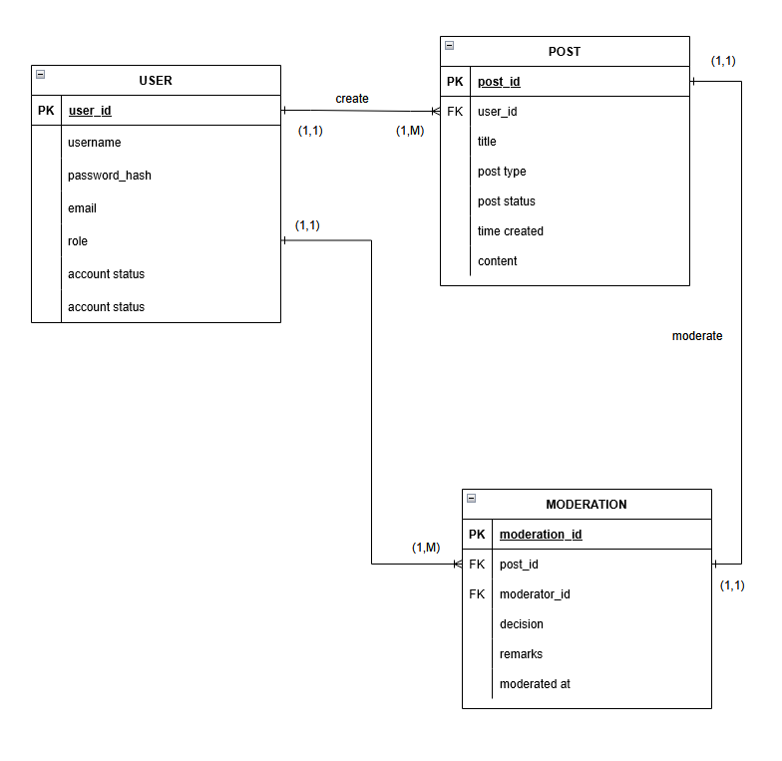

6.0 Component Design
6.1 UML Sequence Diagram

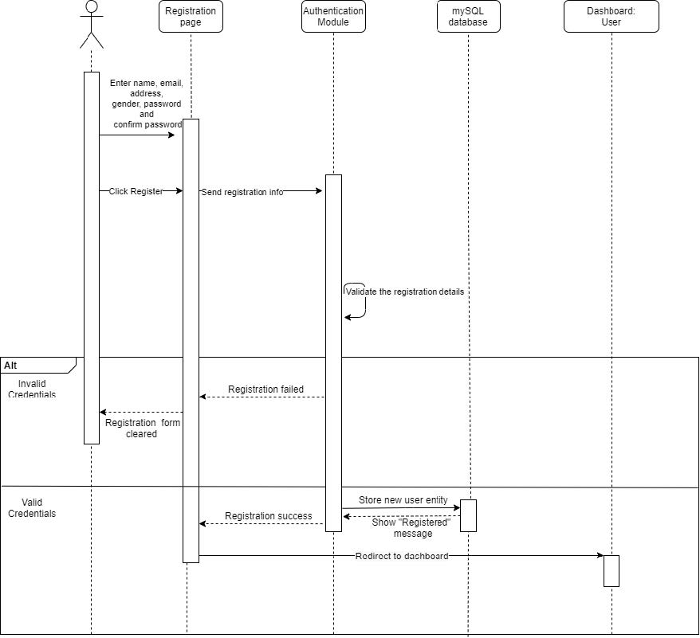
Sequence diagram for registration

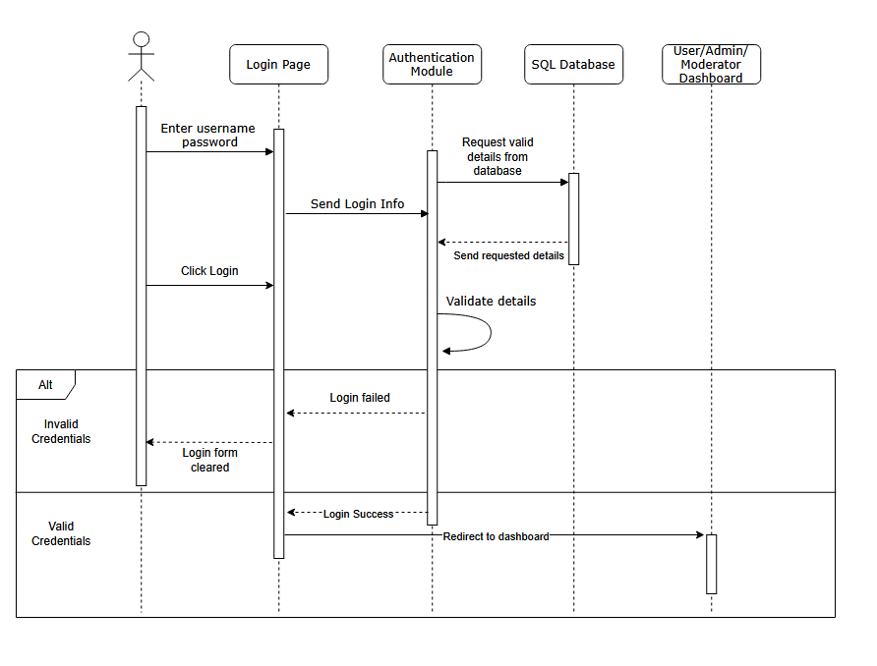
Login Page

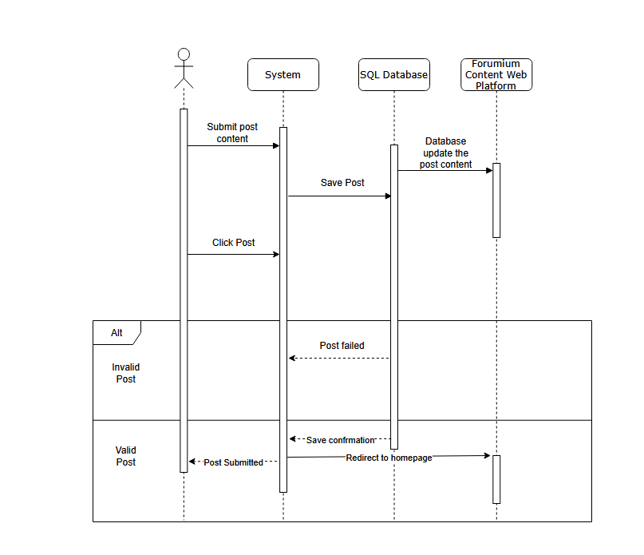
Create Post
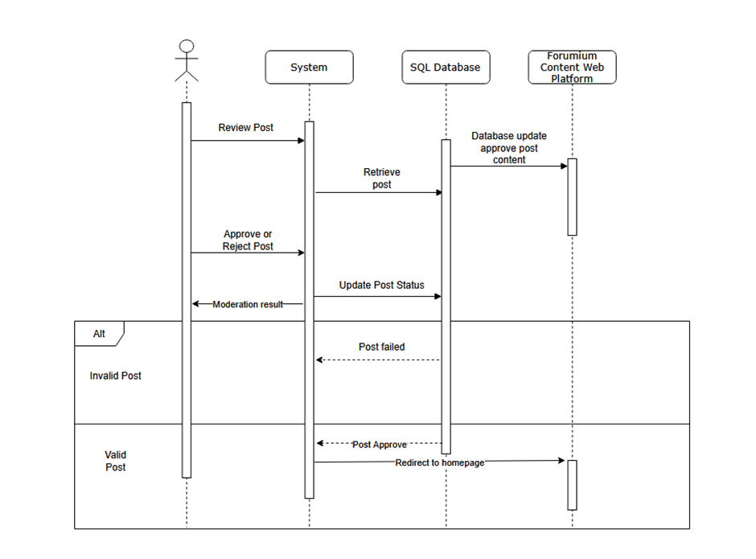
Moderate Post
State-Transition Diagrams (STD)

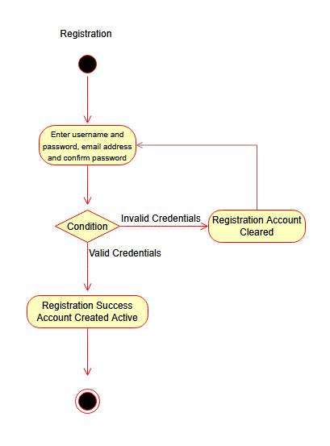

UML diagram for registration

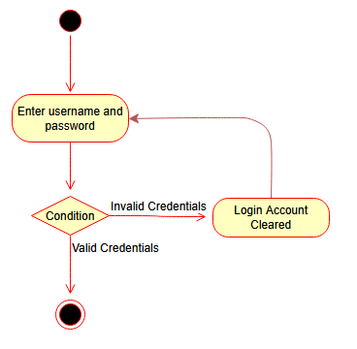
UML Diagram for login

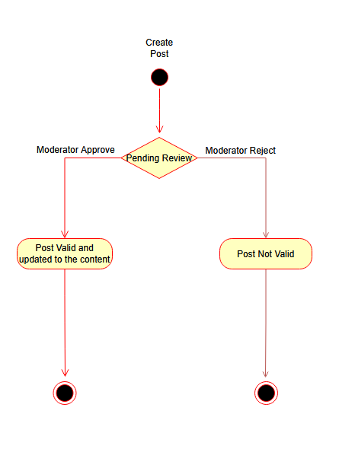
UML Diagram for User Created Post Lifecycle

7.2 Use Case Diagram
Forumium Web Platform
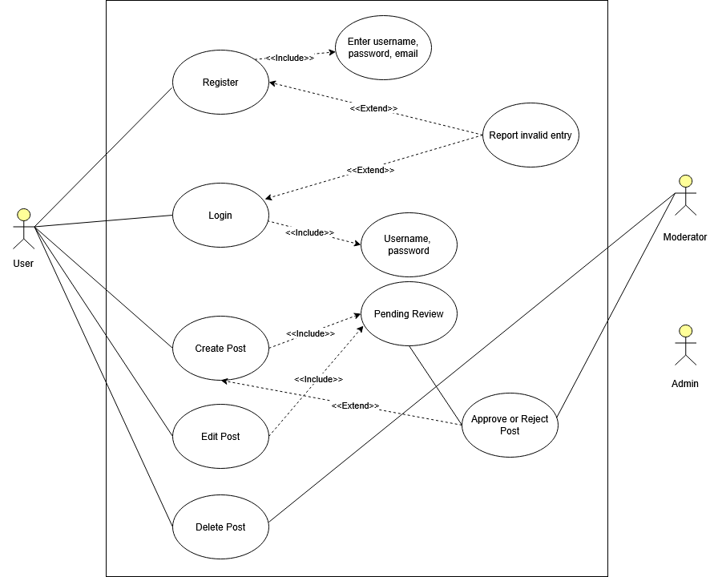
Use case diagram for user’s point of view

Item | Description
Actors | User  Moderator  Admin
Main Success Scenario | - The user accesses the Forum Web Platform and registers an account by entering a valid username, password, and email. After successful registration, the user logs into the system using valid credentials and gains access to the platform features.  - The user then creates a post, which is automatically submitted for pending review. A moderator reviews the post and approves it, after which the system publishes the post and makes it visible to other users. The user may subsequently edit or delete their post as needed while using the platform.
Alternate Flows | - If the user enters invalid or incomplete information during registration or login, the system reports an invalid entry and prompts the user to re-enter the required details. If a submitted post is rejected by the moderator, the system updates the post status to rejected and notifies the user, who may choose to edit and resubmit the post for another review.  - At any point after creating a post, the user may also choose to delete the post, in which case the system removes it and terminates the posting process.

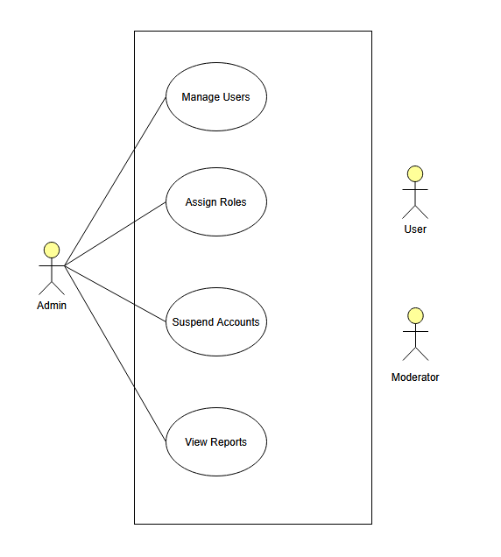
Use case diagram for admin’s point of view

Item | Description
Actors | - Admin  - Manager  - User
Main Success Scenario | - The admin account must exist in the system and have valid administrative privileges. The Forum Web Platform and database must be operational, and the admin must be successfully authenticated before performing any administrative actions.
Alternate Flows | - If the admin attempts to manage users or assign roles to a non-existent or invalid account, the system displays an error and prevents the operation.  - If a role assignment or suspension action cannot be completed due to system errors or insufficient privileges, the system notifies the admin and no changes are applied.  - When viewing reports, if report data is unavailable or a system failure occurs, the system informs the admin and allows the admin to retry or exit the function.
Pre-Condition | - The admin account must exist in the system and have valid administrative privileges. The Forum Web Platform and database must be operational, and the admin must be successfully authenticated before performing any administrative actions.

8.0 Human Interface Design
A web platform's "initial impression" is crucial since a poorly designed website may deter and disappoint potential users. Therefore, when creating the UI/UX of the online application, the principles of human interface design should be monitored. Bruce Tognozz established a set of essential traits that any interface ought to have. The qualities are as follows:

8.1 Design Principles
1. Anticipation
It should appear as though the design is predicting what the user will do next. For instance, a site designer ought to provide the customer account group with a "book appointment" navigation feature.
2. Communication
The user interface (UI) should show the user's current state of a process or action, such as a text message indicating that a booking slot's approval is pending.
3. Consistency
The online application should maintain a similar UI layout, design, and functionality.
4. Restricted autonomy
Ensuring that there is a mechanism of authentication for access to critical data to prevent compromising data integrity.
5. Efficiency
The design should be simple to use and shouldn't interfere with the user's workflow or ability to perform tasks.
6. Adaptability
The web application can be accessed by the user either randomly or sequentially. A navigation bar could be used to do this.
7. Focus
The website's content should put the needs and actions of the user first. As a result, it must show the pertinent data in the main emphasis.
8. Fitt's law
According to Fitt's law, the ratio of the target's width to its distance determines how long it will take to go there quickly.
9. An object with a human interaction
A collection of reusable web design content already exists. You don't have to start from scratch.
10. Latency reduction
Users need not be concerned with the internal operation of the system. If they are required to wait, indicate it with some graphical content like rotating wheels, or a loading sign etc.
11. Learnability
The web should not have too steep a learning curve. It is functions should be clear cut and can be easily learnt.
12. Metaphors
Simulate other real events that have similar operational functions with the web. For example, recreating a physical notebook design for the appointment log system.
13. Maintain work product integrity
Whatever the user had keyed-in or entered a value or commanded should be recognize and stored in the system without

14. Readability
If there is text, it should be made readable no matter the age group of the user.
15. Track state
This design involves the use of web cookies to retain some of the browsing history of the user.
16. Visible navigation
The interface should function as if the user is always in the same place.

